

**LG LS-UC2468RMO (2 Ton)**

**Rs. 89,000/-**

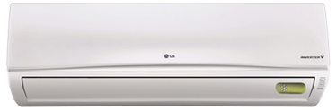

**Product Features**

* Multi- Mode for Installation
* Free Setting of Air Discharge Duct
* dry function
* wide voltage
* active PFC technology

**Specification**

**Type** Wall Mounted Split AC

**Cooling (Btu/h)** 42000

**Voltage (V)** 220-240

**Power Input (W)** 3200

**EER (Btu/W-h-W/W)** 6.5-2.7